Máquinas Simples - Ventaja Mecánica:

Poleas y aparejos

Pasco - SE-8685

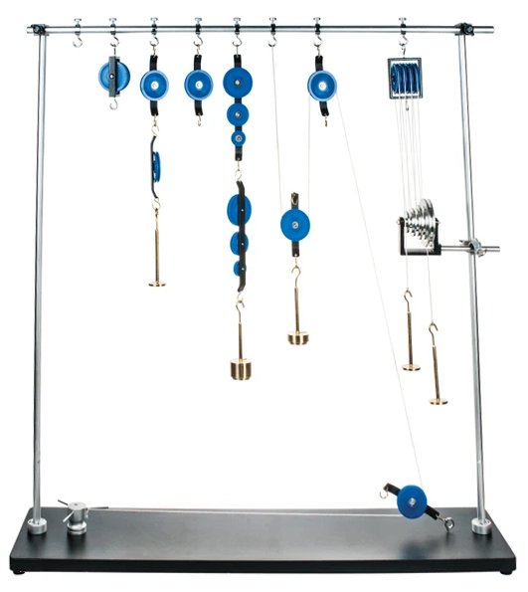

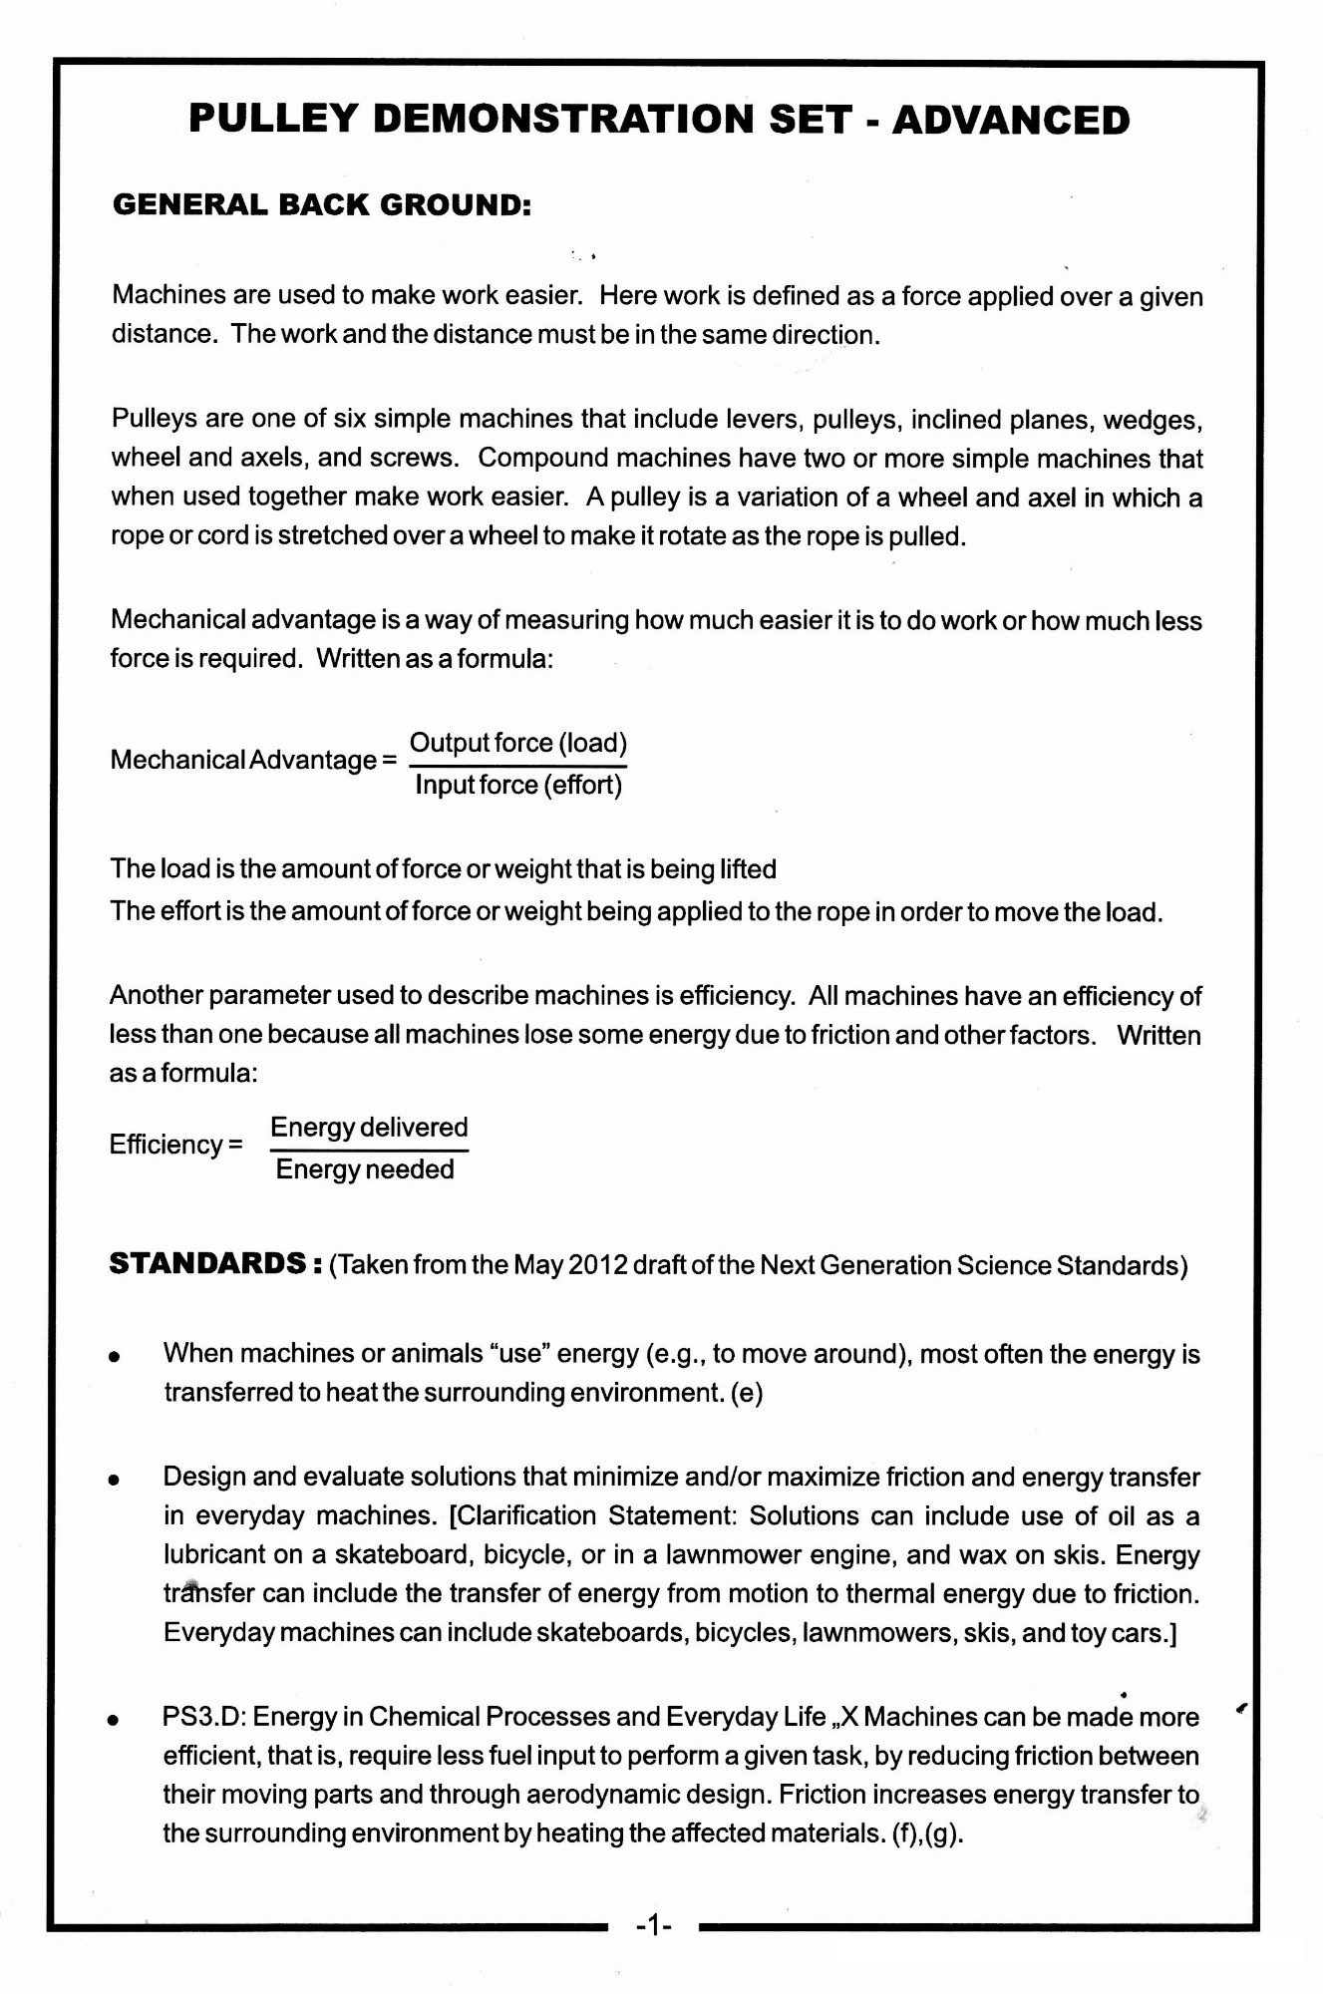
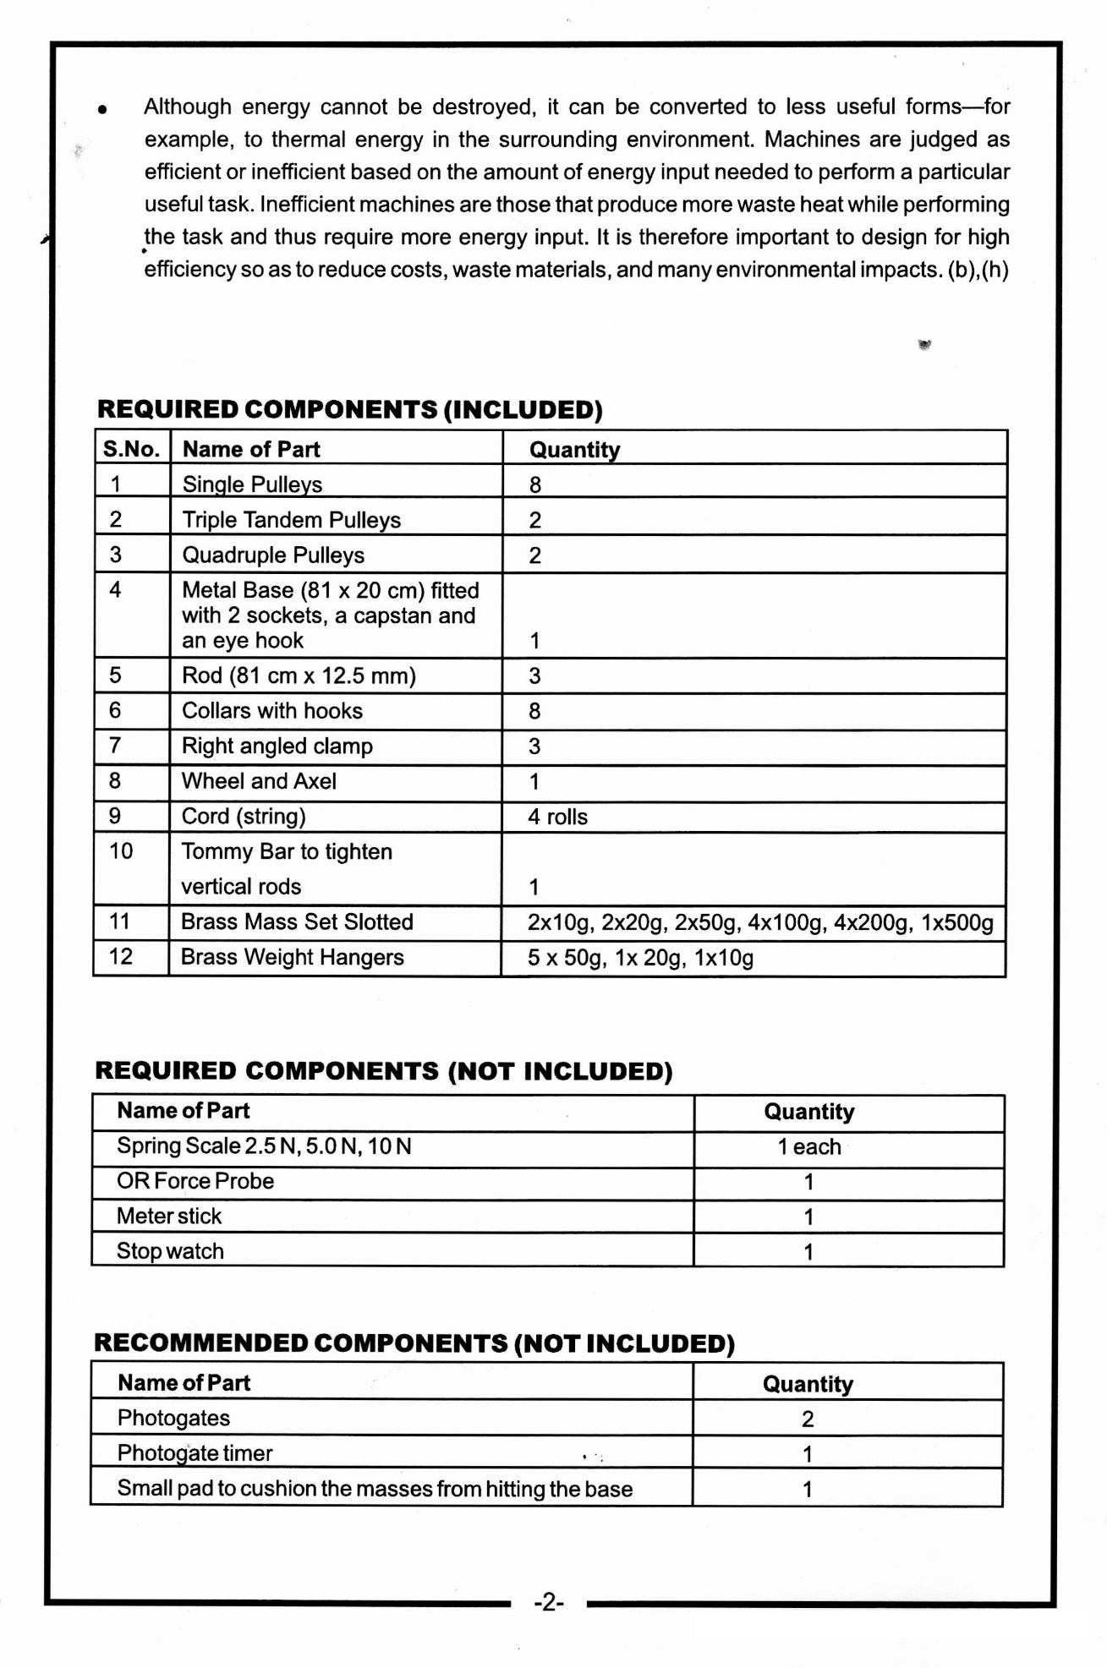
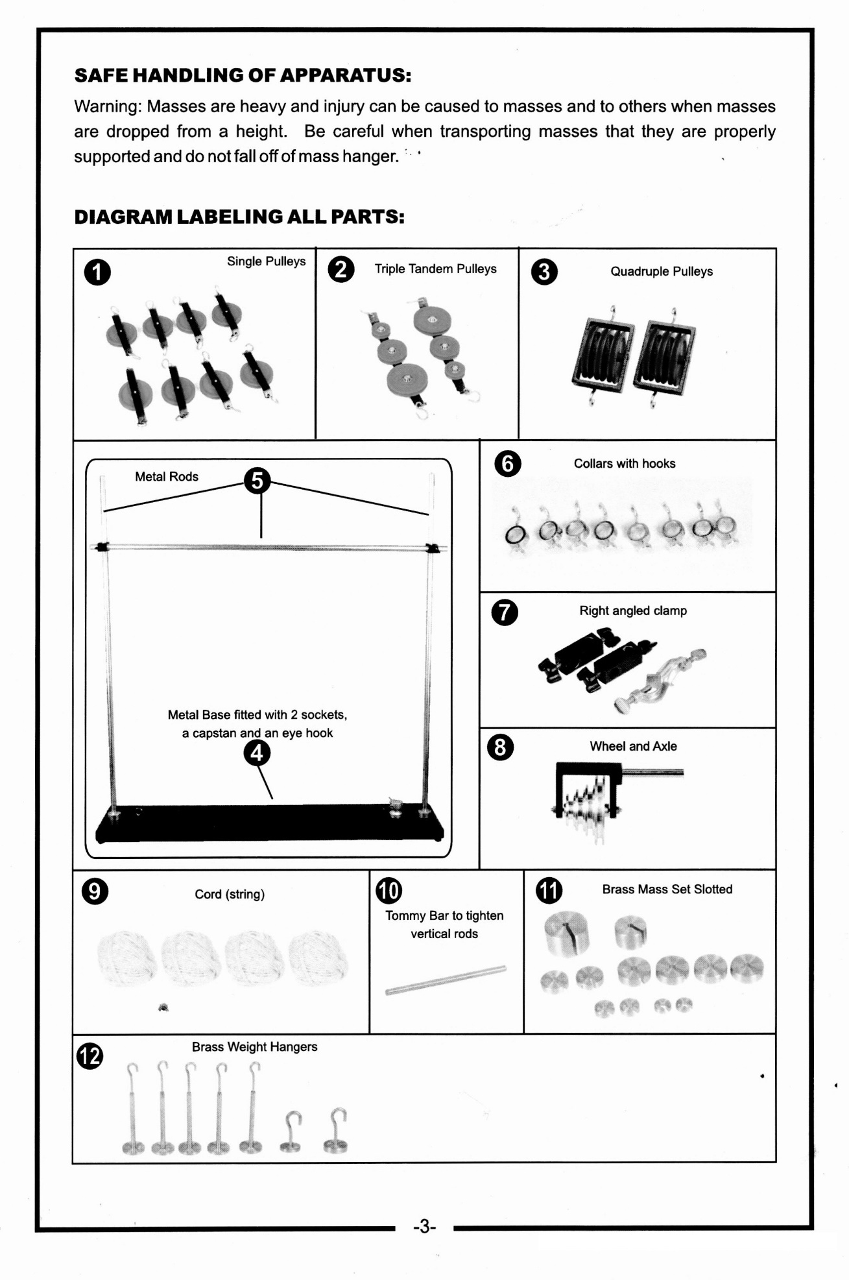
ACTIVITY 1: A HORSE AND HIS SADDLE (TEACHER ANSWERS)
PROCEDURE:
- Measure the weight in Newtons of a 200 gram hook mass and record your answer below:
- Attach a 5.0 N spring scale to one end of the rope and attach a 200. gram mass to the other end of the rope.
- Drape the rope over the bar and pull the mass with the spring scale. Record the force used to pull a 200. gram mass at a constant velocity in the chart below.
- Now drape the rope over the pulley and again pull the mass with the spring scale. Record the force used to pull a 200. gram mass at a constant velocity in the chart below.
DATA:
Original Weight of the 200 g mass 2.0 N
Force required to pull the 200 g mass overthe bar 4.25 N
Force required to pull the 200 g mass overthe pulley 2.1 N

DATA ANALYSIS:
1. Calculate the efficiency of the pulley in diagram 1:

,_„. . Energy delivered Force*distance 2.0 N
Efficiency = — = = = 0.47
Energy needed Force* distance 4.25 N
- Calculate the efficiency of the pulley in diagram 2:

,_„. . Energy delivered Force*distance 2.0 N _._
Efficiency = — = = = 0.95
Energyneeded Force* distance 2.1 N
- Calculate the mechanical advantage of the pulley in diagram 1 & 2. Show all work including formula and substitution with units.

Output force (load) 2.0N
Mechanical Advantage = 1 = =0.47
In put force (effort) 4.25 N

... Output force (load) 2.0 N
Mechanical Advantage = - - = =0.95
In put force (effort) 2.1 N

CONCLUSION:
- Using one pulley (or one tree branch) does not give the thief any mechanical advantage. Why would the thief put the rope over the tree branch in the first place?

Using one pulley can be helpful because it can change the direction you need to apply a force. The horse could now pull up on the safe instead of trying to drag it and scrap against the sides of the hole.
- Why was the second experiment with the pulley more efficient then the first set up?

The pulley reduced the amount of friction to almost nothing. In the first experiment we lost almost half our energy due to friction.

3. Why was the horse able to pull the safe out using the saddle?

The surface of the saddle was smooth and the tree branch was rough. We can assume there was less friction between the rope and the saddle and therefore the horse was able to pull the safe up and out of the hole.

Name: Date:

Lab Section:

BACKGROUND:
Efficiency is one way of measuring how much energy is lost by a machine as it does work. The formula for efficiency is:
Efficiency = Energy delivered Energy needed

Mechanical advantage is a way of measuring how much easier it is to do work or how much less force is required. Written as a formula:
Mechanical Advantage = Output force (load)
Input force (effort)

The load is the amount of force or weight that is being lifted
The effort is the amount of force or weight being applied to the rope in order to move the load.

You are sitting at home watching an old western with your Grandmother, who is really into Westerns, and see pulleys used in two different ways. In the first scene a criminal tries to pull a heavy safe out of a hole in the ground by tying a rope to the safe and then wrapping the rope over a branch of the tree. At first he can't get his horse to pull the safe up. Then he gets an idea and puts the horse's saddle over the tree limb and then puts the rope on top of the saddle and is able to pull the safe out of the ground.

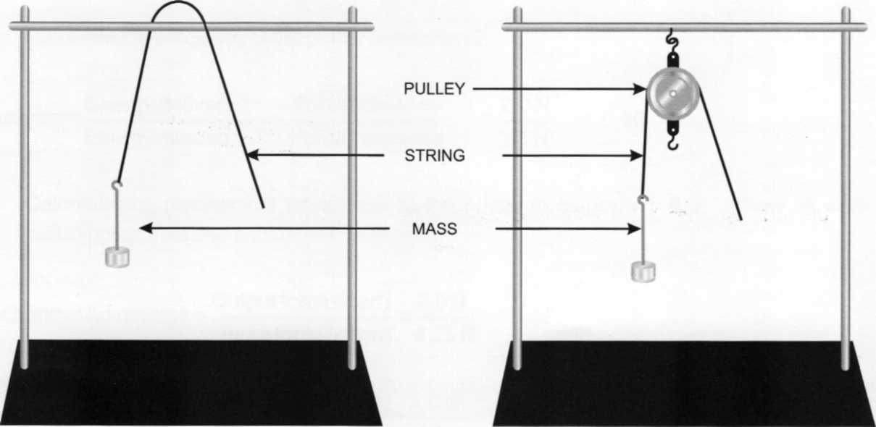
Conduct the following experiment and use your results to help explain why the horse succeeds the second time.
Diagram 1: Diagram 2:
Horse using only the tree limb Horse using the saddle

PROCEDURE:
- Measure the weight in Newtons of a 200 gram hook mass and record your answer below:
- Attach a 5.0 N spring scale to one end of the rope and attach a 200. gram mass to the other end of the rope.
- Drape the rope over the bar and pull the mass with the spring scale. Record the force used to pull a 200. gram mass at a constant velocity in the chart below.
- Now drape the rope overthe pulley and again pull the mass with the spring scale. Record the force used to pull a 200. gram mass at a constant velocity in the chart below.

DATA:
Original Weight of the 200 g mass N
Force required to pull the 200 g mass overthe bar N
Force required to pull the 200 g mass overthe pulley N

DATA ANALYSIS:

1. Calculate the efficiency of the pulley in diagram 1:

2. Calculate the efficiency of the pulley in diagram 2:

3. Calculate the mechanical advantage of the pulley in diagram 1 & 2. Show all work including formula and substitution with units.

CONCLUSION:
Using one pulley (or one tree branch) does not give the thief any mechanical advantage. Why would the thief put the rope over the tree branch in the first place?

2. Why was the second experiment with the pulley more efficient then the first set up?

3. Why was the horse able to pull the safe out using the saddle?

ACTIVITY 2: MECHANICAL ADVANTAGE ASSEMBLY OF APPARATUS:
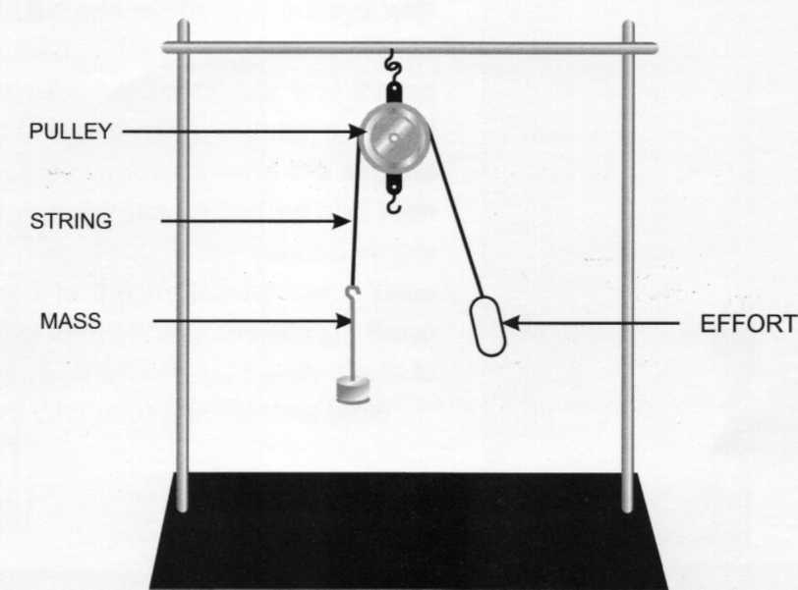

EXPERIMENT 1:

Adding a Pulley, efficiency and mechanical advantage
- Have students suspend a pulley from the apparatus as shown above and label the load and the effort. Use a 500 gram mass for the load and then slowly add effort until the load just starts to move upward. Record these values in your data table.
- Move the load a distance of 10 cm from its original position and record how far the effort moves from its original position in your data table.
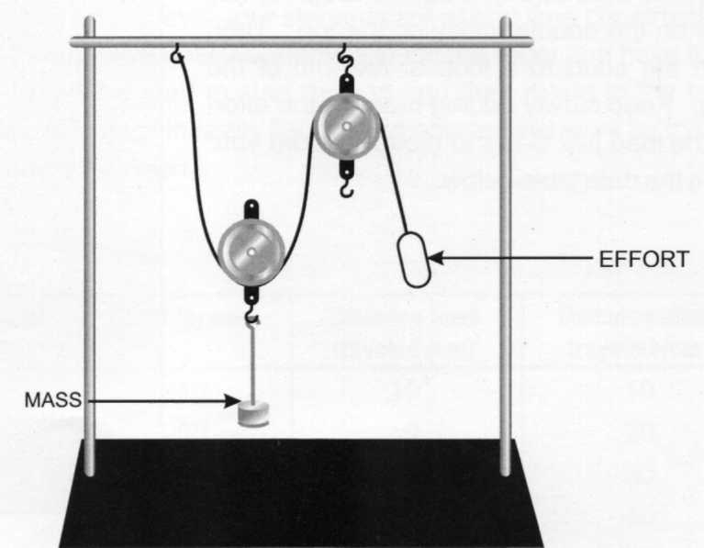

3. Have students add one pulley into the system by setting up the system as shown above. Use a 500 gram mass for the load and then slowly add effort until the load starts to move upward.
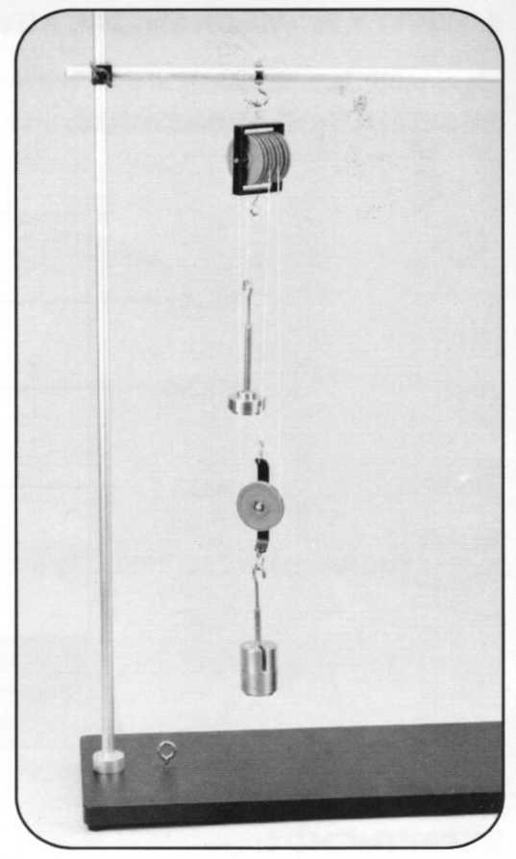

4. Set up three pulleys as shown in the diagram above. Start by attaching one end of the string to the top hook of a single pulley and then attach the load to the bottom hook of this pulley. Take the loose end of the string and feed it through one of the top two pulleys and suspend the double pulley from the horizontal bar. Loop the string around the bottom single pulley and then thread it back through empty pulley on the double pulley on the top. Then attach the effort to a loop at the end of the string. Keep slowly adding mass to the effort until the load just starts to move. Record your data in the data table below.
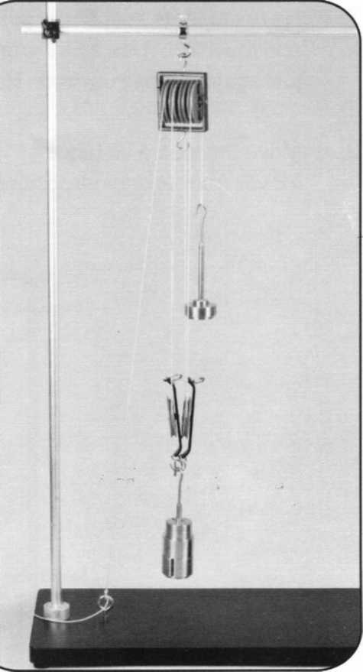

5. Set up a system of four pulleys as shown in the diagram above. To start tie one end of the string to the top of the horizontal bar. Add the load to one of the double pulleys and thread the string around one of the two pulleys with the load attached. Hang the second double pulley set from the horizontal bar and thread string around one of these two pulleys. Send the string back down and around the second empty pulley with the load attached and then send the string up through the second empty pulley attached to the horizontal bar. Then attach the effort to the end of the string. Keep adding mass until the load just barely starts to move. Record your results in the data table.
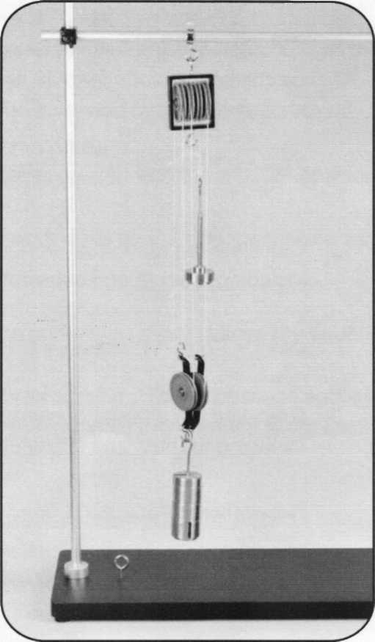

6. Make a system of five pulleys by doing the following. Attach one end of your string to the top hook of the double pulley with a knot. Attach your load to the other hook on the bottom of the double pulley. Attach the other double pulley to the horizontal bar. Take the string and thread it through the one of the two top pulleys and then bring the string down to go through the bottom double pulley attached to the load. Then bring the string up again and go through the second pulley on the top. Bring the string down and go through the second pulley on the bottom. Attach one more single pulley to the top horizontal bar and then thread the string through this pulley. Attach the effort to the end of the string. Add mass to the effort until the load just begins to rise. Record your data on the data table below.
Number of | Load (grams) | Effort (grams) | Distance load | Distance effort
Pulleys Used |  |  | traveled (cm) | traveled (cm)
1 | 500 | 510 | 10 | 10
2 | 500 | 260 | 10 | 20
3 | 500 | 180 | 10 | 30
4 | 500 | 130 | 10 | 40
5 | 500 | 110 | 10 | 50
DATA TABLE:
(Note to Teacher: Depending on the level your students are at and time constraints, you may be able to set up the one through five pulley systems around the room and have the students find the necessary effort to get the load to start moving and then rotate to the next station. However there is valuable experience in really figuring out how pulleys work by trying to figure out how to set the system up on their own.)

1. Calculate the force of the load and the force of the effort in Newtons. Show a sample calculation Include formula and substitution with units.

1000

... . mass(in grams)*acceleration due to gravity 500g*9.8 m/s²
Force = Weight = -—- - -= - = 4.9 N
1000 (to convert grams to kg)

- Calculate the amount of work done to lift the 500g load with 4 pulleys. Show all work including formula and substitution with units.

Work = Force * Distance = 0.130kg*9.8m/s²*0.40m = 0.51 J
- Calculate the amount of energy gained by the 500g load with 4 pulleys. Show all work including formula and substitution with units.

Gravitational Potential Energy = mass*acceleration due to gravity*change in height
= 0.500kg*9.8 m/s²*0.10m = 0.49 J
- Calculate the efficiency and mechanical advantage for each system of pulleys. Show a sample calculation for both the efficiency and mechanical advantage. Include formula and substitution with units.

r-zr . Energy delivered Force*distance = 0.49 J
Efficiency = — = = 0.96
Energy needed Force * distance 0.51 J

_ Output force (load) = 4.9 N
Mechanical Advantage =
Input force (effort) 1.3 N

Fill out the following chart with your calculations:
= 3.8

Number of Pulleys | Force of load (N) | Force of Effort (N) | Work done by effort (J) | Energy gained by Load (J) | Efficiency | Mechanical Advantage
1 | 4.9 | 5.00 | 0.50 | 0.49 | 0.98 | 1.0
2 | 4.9 | 2.55 | 0.51 | 0.49 | 0.96 | 1.9
3 | 4.9 | 1.76 | 0.53 | 0.49 | 0.93 | 2.8
4 | 4.9 | 1.27 | 0.51 | 0.49 | 0.96 | 3.8
5 | 4.9 | 1.08 | 0.54 | 0.49 | 0.91 | 4.5

CONCLUSION QUESTIONS:
- Describe the relationship between the number of pulleys used and the amount of force needed by the effort.
As the amount of pulleys increased, the amount of force needed by the effort decreased.
- Describe the relationship between the number of pulleys used and the amount of work done by the effort.
As the amount of pulleys increased the amount of work done by the effort remained the same.
- What happens to the efficiency of your machine (the pulleys) as more pulleys are added to the system?
As more pulleys are added the efficiency seems to get smaller. This is because adding more pulleys adds more friction, also adding more pulleys adds more weight to the load, even though the pulleys are assumed to have no mass, they still do.
- What would the efficiency of the machine be if we used an "ideal pulley"? Here an "ideal pulley" means that the pulley is frictionless and massless.
An ideal pulley would make the machine 100% efficient or have an efficiency of 1.
- In a world with "ideal pulleys" what would the mechanical advantage of the 5 pulley system be? How close was your result? Why was your system of pulleys less than ideal?
An ideal pulley system of five pulleys would have a mechanical advantage of five. My result was 4.5, which is close but slightly lower than an ideal system. I think my system was less than ideal because my pulleys had friction and mass.
- In a world with "ideal pulleys" what would be the relationship between the number of pulleys used and the mechanical advantage?
Each additional pulley increases the mechanical advantage by 1.
- To a person who has not studied simple machines it may seem that the pulleys are able to create energy. Pulleys allow for less force to be used to pull up a heavier object. The more pulleys the less force is needed. Explain why energy is indeed conserved and not created by pulleys.
Pulleys do in fact allow you to move heavy objects with less force; however, you apply this force over a greater distance. Since work (a form of energy) is the amount of force applied over a distance, then the amount of work you need to do is still the same, however if the force is cut in half, the distance you need to apply the force is doubled. This is how machines work.

ACTIVITY 3:
HOLLYWOOD MOVIE PART 2: BREAKING OUT OF JAIL

You are still watching that western movie with your Grandmother and wouldn't you know it? Our thief from the first scene got himself caught trying to steal the safe and is thrown in jail. First he tries to bend the iron bars with his hands with no luck. But our thief is very clever. Using his knowledge of pulleys again he plans his escape. While the sheriff is snozzing in the front room the thief takes a belt from around his waist and wraps it several times around the iron bars. He attaches one end with a knot to the bar and pulls with all his strength on the other end of the rope to bend the bars and slip through the new wider opening.

Conduct the following experiment to see why the thief is able to bend the iron bars.
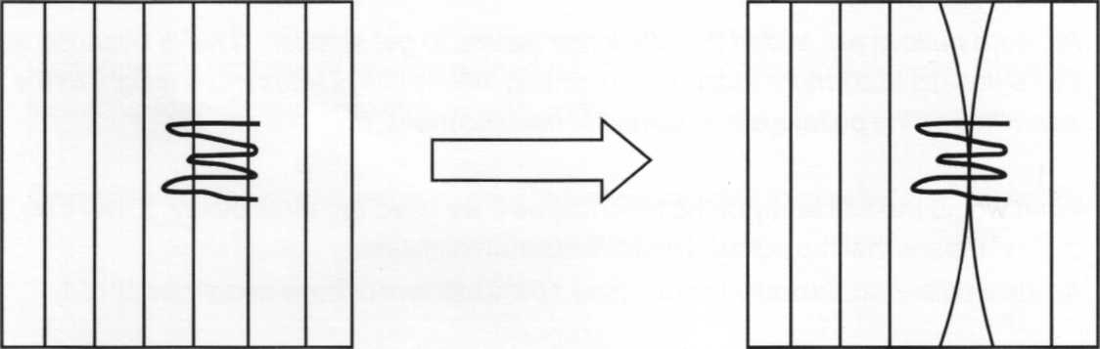

Set up your pulley system like so:
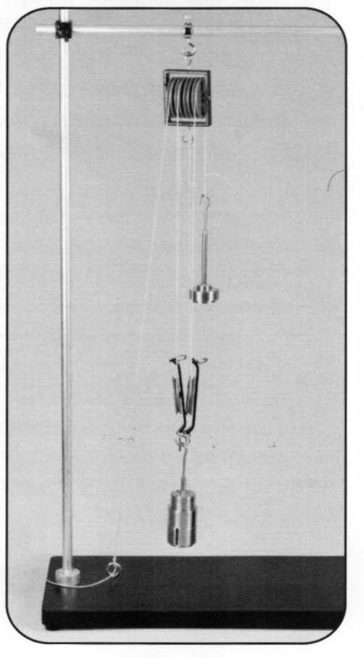
1. Tie your string to the horizontal bar and then thread the string through the pulley on the bottom. Attach a 500 gram mass to the bottom double pulley. Pull the string to make the bottom pulley move upward. Then thread your string through one of the top double pulleys connected to the horizontal bar. Again pull the string to move the 500 gram mass upward.

a. Qualitatively decide which was easier (which required less effort). Was it easier to move the 500 g mass when the string was wrapped around just the bottom pulley or when it was wrapped around the bottom and the top pulley? It was easier to move the pulley when it was wrapped around the bottom and the top pulley.

- Now wrap your string around the second pulley on the bottom and pull the string to move the mass.

- How many pulleys are now rotating when you pull the string? Three
- Is it easier to move the 500 gram mass (the load) when the string is wrapped around three pulleys or two?
It is easier to move the load when the string is wrapped around three pulleys
- Try one to make one more pulley move. This time thread the string through the second top pulley and pull the string.

- Is it easier to move the string with four pulleys moving orthree pulleys moving? It is easier to move the string with four pulleys moving.
- Finish this statement. As the number of pulleys moving is increased, the amount of
effort it takes to move the load decreases .
- If you were the clever thief, how many times would you wrap the rope around the bars?
If I were the clever thief I would wrap the rope around the bars as many times as it would fit.
- Name two ways the clever thief could make it easier to bend the bars?
Increase the amount of times the rope is wrapped around the bars and decrease the amount of friction between the rope and the bars.

ACTIVITY 4:
SPRING SCALE IN THE MIDDLE OF TWO PULLEYS

BACKGROUND:
It is often difficult for students to conceptualize exactly how pulleys work. One common misconception which causes problems when students try to construct free body diagram and solve problems for how quickly something is accelerating is the idea of tension in a string.

Before the students come into class set up the following apparatus as shown in the diagram below:
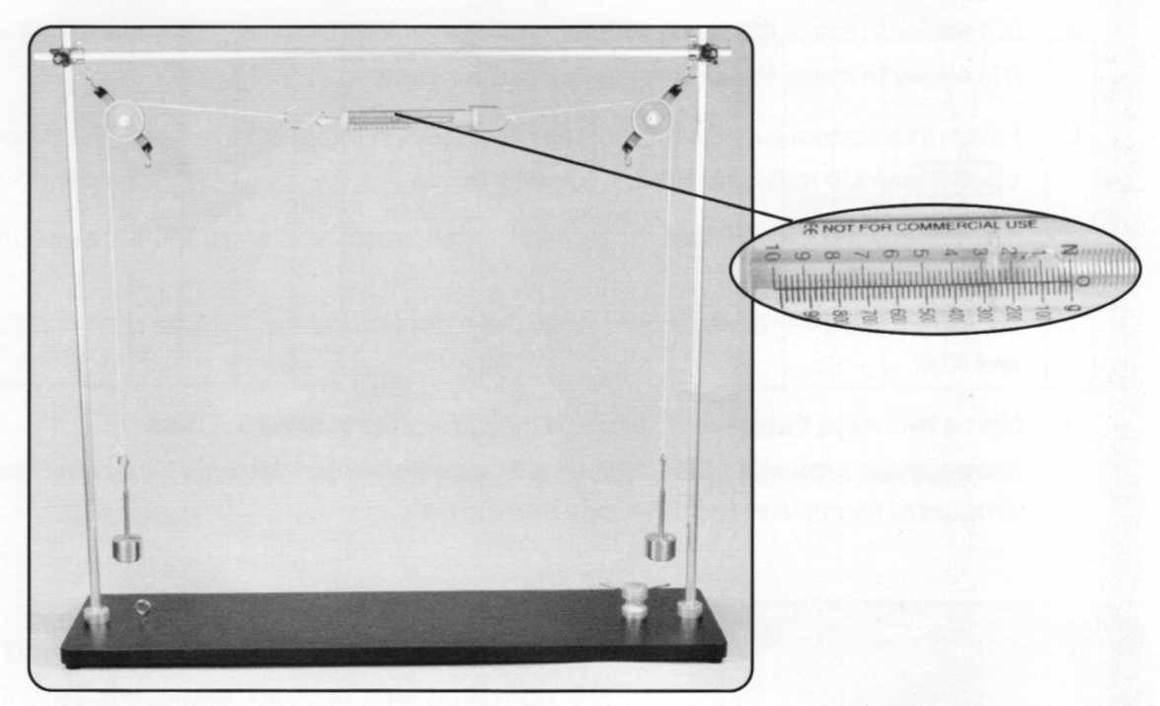
Suspend an equal weight from each pulley so that the apparatus is in equilibrium. One side should be higher than the other side. Wrap masking tape around the scale readings so that students cannot tell what the spring scale reads.
In small groups have the students answer the following question: What is the reading on the spring scale? Why do you think this way?
Have each small group present their answers and explanations until all or most of the class agree, then remove the masking tape to reveal the scale to read about 2.5 N or 250 g. If the class is having a lively debate there are other questions you can ask such as, if a spring scale were put in position '1' or '2', what would the readings of those scales be? If the mass was hanging from the bar instead of off the pulley, what would the reading on the spring scale be. Encourage students to test out answers for themselves.
Ask the students if the system is in equilibrium. Have the students draw a free body diagram for the pulley, each of the masses and the spring scale.
These exercises will help students to understand that when using a single pulley, the amount of force needed to lift an object is equal to that object's weight. The pulley only changes the direction of the applied force.

ACTIVITY 5: ATWOOD MACHINE

BACKGROUND:
The classic Atwood Machine was used to help students understand how to apply Newton's Laws.

As we know from previous activities:
- Asingle pulley can be used to change the direction of a force
- The tension in the rope or cord is uniform throughout the cord (assuming no friction of and an ideal massless pulley.
Students should now be ready to apply this knowledge to solve more complex physics problems.

Newton's first law states "an object in motion tends to stay in motion unless acted upon by an outside force and an object at rest tends to stay at rest unless acted upon by an outside force.

Newton's second law is "F=ma"
Newton's third law is "For every action there is an equal and opposite reaction." HOW TO SET UP YOUR ATWOOD MACHINE:

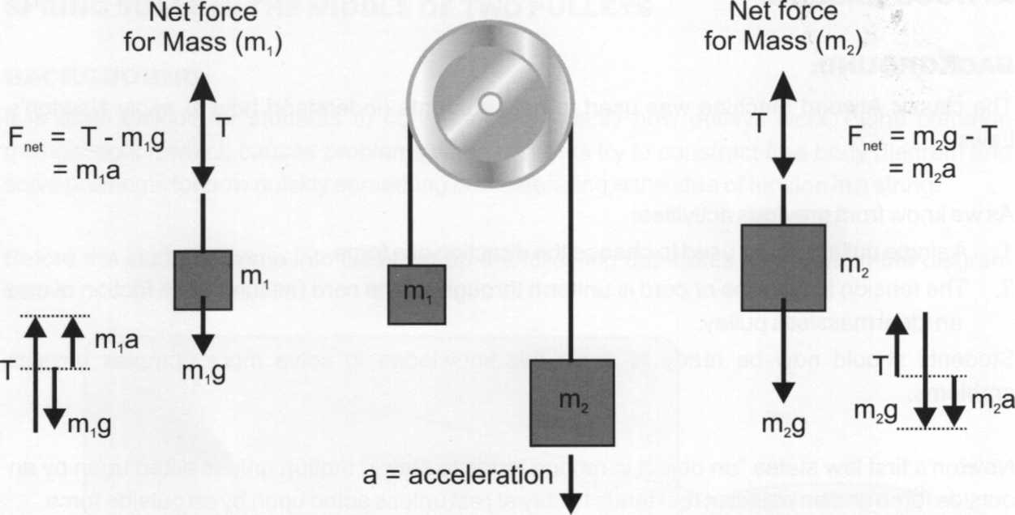
- The pulley is massless and the string does not stretch therefore T (tension) is the same for both sides of the Atwood Machine, therefor a (acceleration) is the same for both sides of the Atwood Machine.
ATWOOD MACHINE : neglecting pulley mass
T = m,g + m,a Substituting T into the equation for m₂ gives
m,a - m,a - m,a = m₂a The equation of motion for the two-mass system is then:
. , . . (mo-m,) (m₂-m₁)g = (m₁ + m₂)a or a = —_——
(m₁ + m₂)
TEACHER'S INSTRUCTIONS: SETUP:

1.
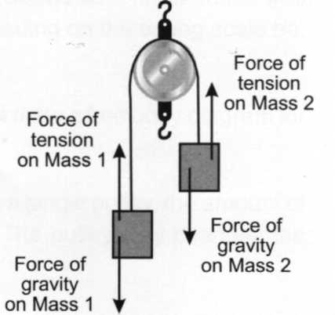

2.

5.
Hang a single pulley off one of the collars with hooks attached to the vertical bar on your apparatus.
Loop a single piece of cord over the pulley and on the left end attach a 50g weight hanger with a 10Og slotted mass. This will be mass 1.
On the other end (right hand side) attach another 50g weight hanger and attach a 100g slotted mass and a 10g slotted mass. This will be mass 2.
Since mass 2 is heavier, do not let go of it, but help it to slowly reach a rest position at the base of the apparatus.
Draw a diagram in the space below of your apparatus. Treat each weight hanger as a separate system and draw two free body diagrams, one for each weight hangerº. Label all the forces on your free body diagram.

- Are any of these forces equal in magnitude? If so name which ones in the space provided below.
The tension force on mass 1 = the tension force on mass 2
- Use Newton's second law, F_{net} = ma to find the acceleration of the masses. Write the acceleration in terms of m, (mass 1), m₂ (mass 2), and "g" (acceleration due to gravity). Assume that m₂ accelerates downward.
_ (nv-mjg (nvm₂)

Calculate the theoretical acceleration, a = (0-160kg-0.150kg)(9.81m/s-) ₌ (0.160kg + 0.150kg)

9. Place a cushion or other soft landing pad on the base for the masses to fall into. Do not catch the mass with your hand. Hold mass two up and release allowing it to fall down to the cushion. Find the acceleration using either a stopwatch or a photogate timer.
To use a stopwatch: Record the amount of time it takes for the mass to fall from rest a given distance. Assume that the mass falls from rest. Use the formula distance equals 14 acceleration * time^{A}2 and solve for acceleration.
To use a photo gate: Have the photo gates set up a fixed distance apart. Have the timing start when mass two is released from rest. The second photo gate will stop timing when the masses break the beam. Be sure to start the masses from rest just above the first photo gate. Use the formula distance equals 14 acceleration * time^{A}2 and solve for acceleration.
To use video software: Take a video of the Atwood Machine from rest to when the masses hit the cushion. Be sure to have some way to measure distance in the video. Count the number of frames it takes for the mass to fall a certain distance. Use the number of frames per second your video records at to get the time and then use the formula distance equals V* acceleration * time^{A}2 and solve for acceleration.

10. Find the actual acceleration of the masses. Show formula and substitution with units.

a = 2*d/(t²) = 2 (0.383)/(1.5s)² = 0.34 m/s²

6. Find the percent error between your actual and theoretical values for acceleration. What are some reasons for discrepancies between the two values?
(actual-theoretical) ,__ (0.34-0.316) ... _ ...
% error = x 100 = - - x 100= 6.9%
Actual 0.34 There are many reasons why the theoretical values do not match exactly with the actual values for acceleration. These calculations assume the use of an ideal pulley. Our pulley has both mass and friction which would cause the actual value to be lower than the theoretical value. There is also human error in using a stopwatch and in measuring a distance.

Name:
Date:

Lab Section:

SETUP:
- Hang a single pulley off one of the collars with hooks attached to the vertical bar on your apparatus.
- Loop a single piece of cord over the pulley and on the left end attach a 50g weight hanger with a 10Og slotted mass. This will be mass 1.
- On the other end (right hand side) attach another 50g weight hanger and attach a 100g slotted mass and a 10g slotted mass. This will be mass 2.
- Since mass 2 is heavier, do not let go of it, but help it to slowly reach a rest position at the base of the apparatus.
- Draw a diagram in the space below of your apparatus. Treat each weight hanger as a separate system and draw two free body diagrams, one for each weight hanger. Label all the forces on yourfree body diagram.
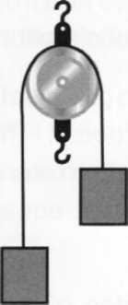

6. Are any of these forces equal in magnitude? If so name which ones in the space provided below.

7. Calculate the theoretical acceleration.

- Place a cushion or other soft landing pad on the base for the masses to fall into. Do not catch the mass with your hand. Hold mass two up and release allowing it to fall down to the cushion. Find the acceleration using either a stopwatch or a photogate timer.
To use a stopwatch: Record the amount of time it takes for the mass to fall from rest a given distance. Assume that the mass falls from rest. Use the formula distance equals %A acceleration * time^{A}2 and solve for acceleration.

To use a photo gate: Have the photo gates set up a fixed distance apart. Have the timing start when mass two is released from rest. The second photo gate will stop timing when the masses break the beam. Be sure to start the masses from rest just above the first photo gate. Use the formula distance equals V2 acceleration * time^{A}2 and solve for acceleration.

To use video software : Take a video of the Atwood Machine from rest to when the masses hit the cushion. Be sure to have some way to measure distance in the video. Count the number of frames it takes for the mass to fall a certain distance. Use the number of frames per second your video records at to get the time and then use the formula distance equals V2 acceleration * time^{A}2 and solve for acceleration.
- Find the actual acceleration of the masses. Show formula and substitution with units.

10. Find the percent error between your actual and theoretical values for acceleration. What are some reasons for discrepancies between the two values?

